# DWM Practical 8

|  |
| --- |
| Implementation of Spatial / Web mining algorithms. |

**Aim: Implementation spatial / web mining algorithms.**

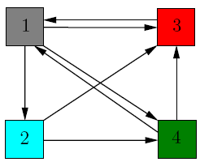**Objective: WAP to implement Page rank algorithm for a given graph**

**References:**

[**http://pi.math.cornell.edu/~mec/Winter2009/RalucaRemus/Lecture3/lecture3.html**](http://pi.math.cornell.edu/~mec/Winter2009/RalucaRemus/Lecture3/lecture3.html)

[**http://www.cs.princeton.edu/~chazelle/courses/BIB/pagerank.htm**](http://www.cs.princeton.edu/~chazelle/courses/BIB/pagerank.htm)

[**https://www.youtube.com/watch?v=3_1h13PJkUs**](https://www.youtube.com/watch?v=3_1h13PJkUs)

**Algorithm**

**I/P- initial graph matrix and N –no of nodes,**

**O/P- find page rank vector and k- no of iterations.**

**1) Read n-no.of nodes, initial graph using matrix**

**2) Initial vector V0= [1/n, 1/n, 1/n..ntimes]**

**3) Find M-n*n matrix where m[ij] = 1/k,**

**Where k = no of outgoing links from node j and one of them to node I**

**4) k=0,**

**4) Iterate until converge V**

**Vk= M*V k-1**

**k=k+1;**

**5) Print Vi and K- no of iterations**

**Lab Questions**

**1) Give the efficient approach to handle M and write reason**

**2) Give improvement of Page rank algorithm for spider trap problem and dead end**